Calibration of the LVX2000

- Using the Nozzle Location Editor
- Calibration of the Laser and Nozzle Scan Heights
- Calibration of Machine Offsets
  - by the Laser
  - by the Fine Pitch Camera
- Fine Tuning the X,Y and Angle Offsets
  - of the Laser
  - of the Fine Pitch Camera

1. Using the Nozzle Location Editor
Teaching the X,Y Nozzle Position
- Select the Nozzle Location Editor option from the Editors menu. The window shown in figure 1 will be displayed.
- Click the nozzle #1 (or #2, #3, #4, #5) field located on the displayed table.
- Click the Center On option to Camera.
- Click the Move To X,Y button and the machine will move over the programmed position for this nozzle.
- Using the jog panel, adjust the head position, as needed, so that the camera cross-hair is slightly right (+0.01 in x direction) of center over the nozzle.

TIP: By placing a mirror or really any reflective object under the nozzle rack, it is easy to see the center of the nozzle hole with the camera. Teaching the nozzle pick position slightly right of dead center ensures that the head does not ‘bottom out’ when it is releasing a nozzle. This minimized any lateral force on the nozzle and head and relies on the nozzle magnet to pull the nozzle in to its final resting position.

- Click on the Save X,Y button.
- Repeat steps two through six for each of the other nozzles.
Teaching the Z for Nozzle Pick Up

TIP: The user should get into the habit of physically crouching down to the machine nozzle level while teaching critical operations like z heights. Observing the machine at the working level instead of standing over it will reveal much more detail on how the machine is operating.

- Click the Center On option to Head.
- Click Move to X,Y. The head will move over nozzle #5 (or #4, #3, #2, #1).
- Using the Jog Panel, carefully move the head down switching to a slow speed as the head approaches the nozzle. Continue to move the head down until the nozzle seats into the nozzle holder.
- Click on Get Z.

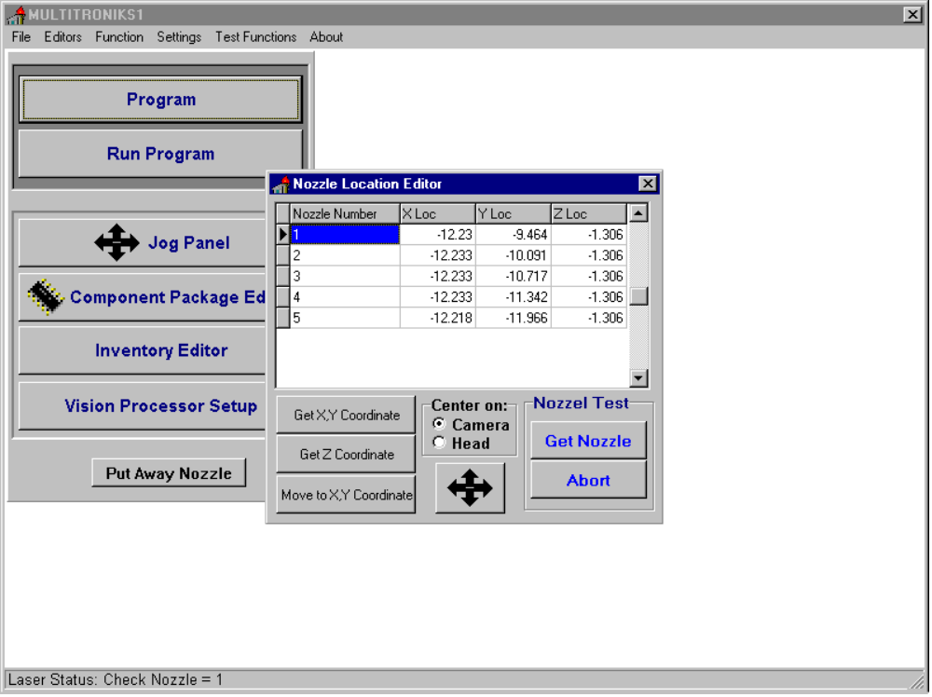

Figure 1

- Because the Z Location should be the same for all nozzles use the value found in the previous step for all nozzles. The user may manually type or use the mouse to copy and paste the Z value for each nozzle.
- Test each nozzle pick position by alternately using the Get Nozzle and Put Nozzle button. When properly taught, picking and placing nozzles will be a quiet and smooth operation.

2. Calibration of the Laser and Nozzle Scan Heights
Finding the Nozzle scan Height
- Choose the Laser Calibration option from the Function menu. The window pictured in figure 2 will be shown.
- Click the nozzle #1 (or #2, #3, #4, #5) field located on the displayed table.
- Click the Get Nozzle button. The machine will pick up the selected nozzle.
- Click the Find Scan Height button. This will start an automatic search procedure to zero in on the z value so that the edge of the nozzle is one step above the plane of the laser.
- The program will return a value and prompt the user to save or discard. Click on Yes to save.
- Click on the Put Nozzle button to return the nozzle to the holder.
- Repeat steps three through six for the other four nozzles.

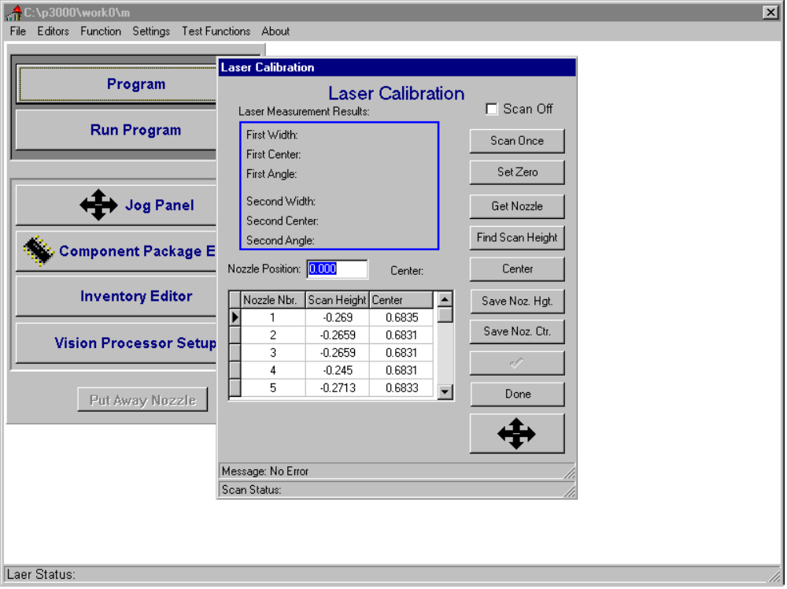

Figure 2

Finding the Nozzle Center.
- Click the nozzle field that contains the three dot nozzle.
- Click the Get Nozzle button. The machine will pick up the selected nozzle.
- Click the Center button. This will start an automatic search procedure to find the center of the nozzle or to be more specific it will find the rotating center of the theta axis.
- The program will return a value and prompt the user to save or discard. Click on Yes to save.
- Because the rotating center of the theta axis is the same for all nozzles use the value found in the previous step for all nozzles. The user may manually type or click the nozzle record and then click Save Center button for each nozzle.
- Click on the Put Nozzle button to return the nozzle to the holder.
- Click the Done button to close the Laser Calibration menu.

3.1 Calibration of Machine Offsets by the Laser

NOTE: Users that have machines equipped with an upward looking camera should skip this section.
TIP: For accurate picking of the calibration component and, therefore, accurate calibration, the user should check the calibration component’s holder for any debris and clean as needed.

- Select the Calibration option from the Function menu.
Setting up the Calibration Component Parameters
- Click the Calibration Coordinate tab. The window pictured in figure 3 will be shown.
- Click the Center On option to Camera and the Calibration option to Pick Point.
- Click the Move To button. The camera will move over the programmed position.
- If the component is sitting to one side in its holder (not centered) the user should manually move the component.

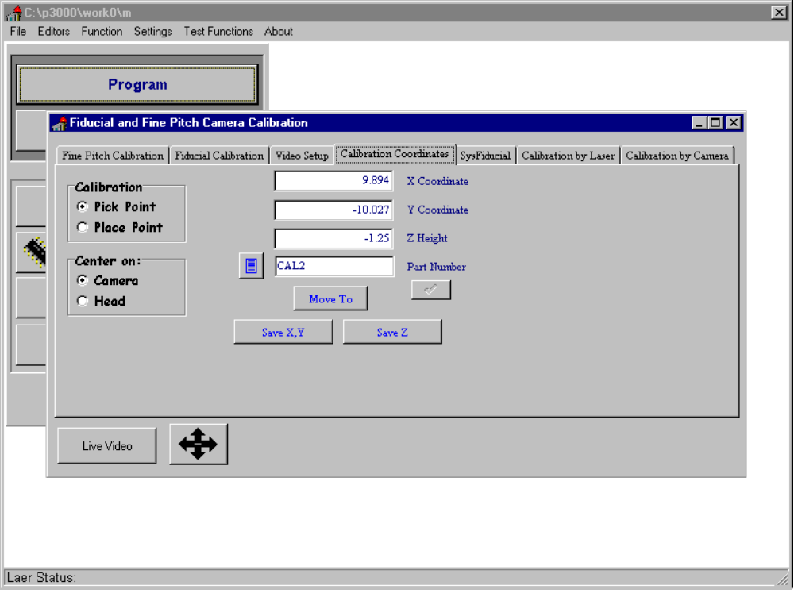
Figure 3

Running the Calibration Procedure
- Click the Calibrate by Laser tab. The window pictured in figure 4 will be shown.
- Click the Start button to begin the automatic calibration. The machine will analyze the top of the calibration component with the fiducial camera and then pick the component. The component will be analyzed by the laser. Finally the component will be put back in its holder.
- The program will return values and prompt the user to save or discard. Typically, the user should click on the Save button.

NOTE: Among the many returned values there are two that are very important. The dx and dy, located on the lower right status bar. These values will approach zero each time the calibration is run. A good calibration will return -0.0005< dx <+0.0005 and -0.0005< dy <+0.0005.

- Repeat steps eight and nine until dx and dy are within specification.
- Close the Calibration window.
- Select the Initialize option from the Function menu. Then select the Initialize Motors option.

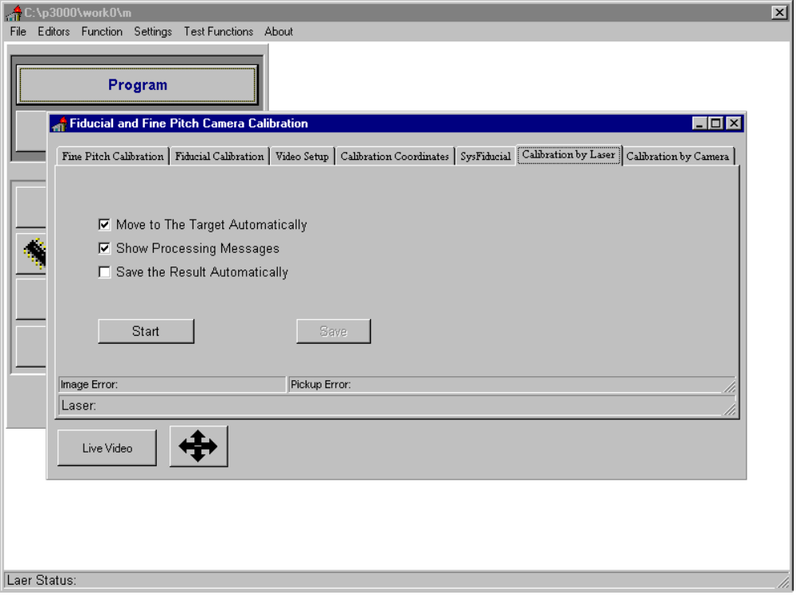

Figure 4

- Calibration of Machine Offsets by the Fine Pitch Camera

NOTE: This section only applies to machines equipped with an upward looking camera.
TIP: For accurate picking of the calibration component and, therefore, accurate calibration, the user should check the calibration component’s holder for any debris and clean as needed.

- Select the Calibration option from the Function menu.
Setting up the Calibration Component Parameters
- Click the Calibration Coordinate tab. The window pictured in figure 3 will be shown.
- Click the Center On option to Camera and the Calibration option to Pick Point.
- Click the Move To button. The camera will move over the programmed position.
- If the component is sitting to one side in its holder (not centered) the user should manually move the component.
Running the Calibration Procedure
- Click the Calibrate by Camera tab. The window pictured in figure 5 will be shown.
- Click the Start button to begin the automatic calibration. The machine will analyze the top of the calibration component with the fiducial camera and then pick the component. The component will be moved to the upward looking camera and analyzed. Finally the component will be put back in its holder.
- The program will return values and prompt the user to save or discard. Typically the user should click on the Save button.

NOTE: Among the many returned values there are two that are very important: the dx and dy, located on the lower right status bar. These values will approach zero each time the calibration is run. A good calibration will return -0.0005< dx <+0.0005 and -0.0005< dy <+0.0005.

- Repeat steps eight and nine until dx and dy are within specification.
- Close the Calibration window.
- Select the Initialize option from the Function menu. Then select the Initialize Motors option.
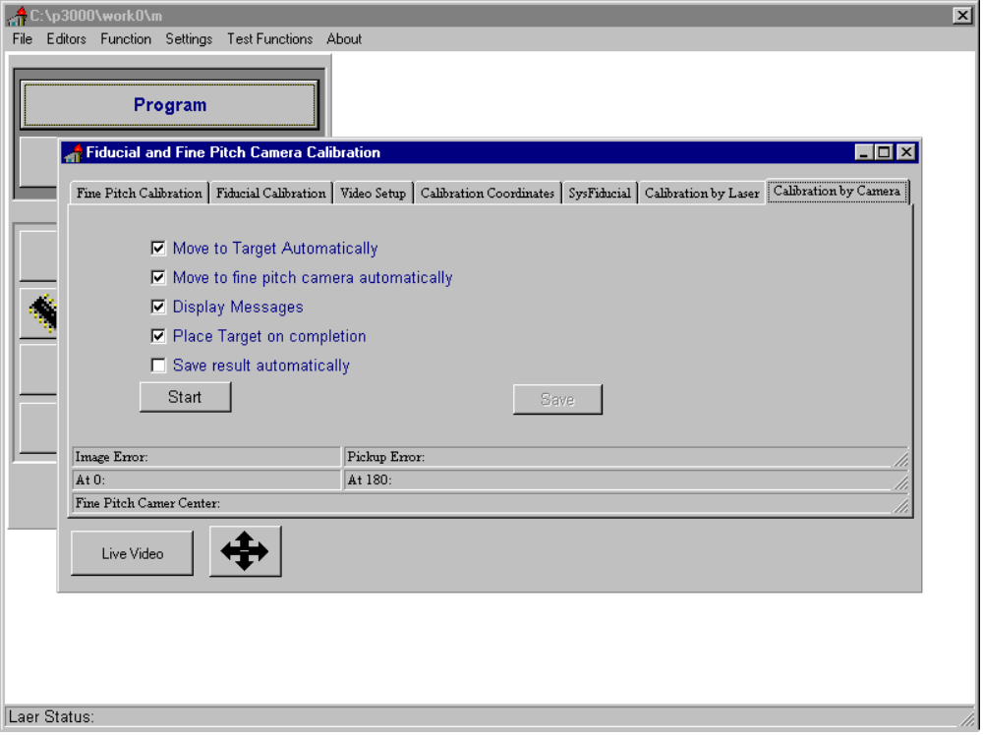

Figure 5

- Fine Tuning of the Offsets and the Offset Angles –

TIP: Fine tuning of the system is a trial and error procedure. To help guaranty accurate placement use a large nozzle; increase the place delay beyond what might normally be necessary; slow the head speed to fifty percent; and recheck part thickness and board base height. Weak double sided tape is also very useful for test placing one part multiple times.

- Fine Tuning of the Laser
- Run the automatic calibration on the machine.
- Place a blank board (any board will do but a blank board works best) with two fiducial marks on the machine. It is critical that this board does not move at all or you will have to start over again. It is recommended that the board be taped to several of the magnetic holders.
- Setup the metal target:
- Define package (us large delays and a slow head speed to get the best placement).
- Define inventory item.
- Define feeder (setup a 1x1 matrix tray at the placement point).
- Create a new program and give it a name
- Teach alignment and fiducials
- Alignment point one should be any point on the left side of the board. Turn vision off and click Get Point.
- Alignment point two can be any point directly right of A1 (zero board angle). Click Get Point.
- With the vision on, teach G1 and G2.
- Test place the metal target. Use weak double sided tape.
- Inspect the placed part and note the cursor error. The center dot on the target is approximately 20 mils (0.020”).
- Using the inspection utility (click Start-Run-Browse to find the file LVXFT.exe and then Run. You can have both programs running at the same time. To ‘minimize’ the utility window click on the button with the underscore symbol, _, in the upper right corner. To bring it back click the LVXFT button on the start bar.), enter the cursor errors of the placed part. The utility will tell you how to read the error and make recommendations for calibration adjustments.
- Make the appropriate changes in the machine calibration based on the recommendations. See below for help in finding the location of the software parameters.
- Repeat steps 6 to 9 until you are satisfied with the placement using the Laser.

4.2 Fine Tuning of the Fine Pitch Camera

NOTE: This section only applies to machines equipped with an upward looking camera.

TIP: The procedure is best done with a large QFP with a fine pitch. Twenty mil pitch is best because the leads and spaces between them are ten mils making it easy to judge the error.
- You must first go through the laser fine tuning procedure because laser adjustment will affect the FP camera adjustment ( FP camera adjustment has no affect on the laser though). Use the same board and fiducials as above. Remember not to move the board in any way, otherwise reset up the board alignment points and then continue here.
- Setup the part you intend to test place.
- Define package (us large delays and a slow head speed to get the best placement).
- Define inventory item.
- Define feeder.
- Define vision parameters.
- Teach three or more placement points (for the test part) on different areas of the board. Also use double sided tape on your placement points.
- Run the assembly.
- Switch to the Component Placement Editor and click the Move To button. Inspect the part using the jog panel by first moving left and right. Then click Move To and jog up and down. Note the cursor to pin error for all four sides.
- Using the inspection utility, enter the cursor errors of the placed parts. You may use the utility to make calibration adjustments recommendations after you have entered three sets of data. The more data you enter the more accurate, statistically, the recommendations will be. Usually, six (two runs of three parts) entries will give meaningful recommendations.
- Make the appropriate changes in the machine calibration based on the recommendations. See the section below for help on changing these parameters.
- Repeat steps 13 to 16 until you are satisfied with the placement using the Fine Pitch Camera.

The system has been fine tuned and the automatic calibration should not be run again. If it is, you must go through this procedure as well. It is advisable to make a back up of your system at this point.

To Enter the X, Y, and angle offsets of the Laser
- Select the System Settings option from the Settings menu.
- Click the Laser tab. Figure 6 will be shown.
- Click the Laser Angle button and adjust the laser angle as needed by manually typing a value in the text box. Click the post button (check mark).
- Click the Fiducial Camera tab.
- Click the Camera Offset to Head button and adjust the X and Y values as needed by manually typing a value in the text box. Click the post button (check mark).

To Enter the angle offset of the FP Camera
- Select the System Settings option from the Settings menu.
- Click the Fine Pitch Camera tab. Figure 7 will be shown.
- Click the Camera 2 Coordinates button and adjust the camera angle as needed by manually typing a value in the text box. Click the post button (check mark).

To View the FP Camera Pixels per Inch
- Select the System Settings option from the Settings menu.
- Click the Fine Pitch Camera tab. Figure 7 will be shown.
- Click the Camera 2 Pixel Resolution button and make note of the value shown.

To Enter the X, Y, and angle offsets of the FP Camera
- Select the Calibration option from the Function menu.
- Click the Fine Pitch Camera tab.
- Click the Reference Mark tab and adjust the X,Y pixel values as needed by manually typing a value in the text box. Click the post button (check mark).

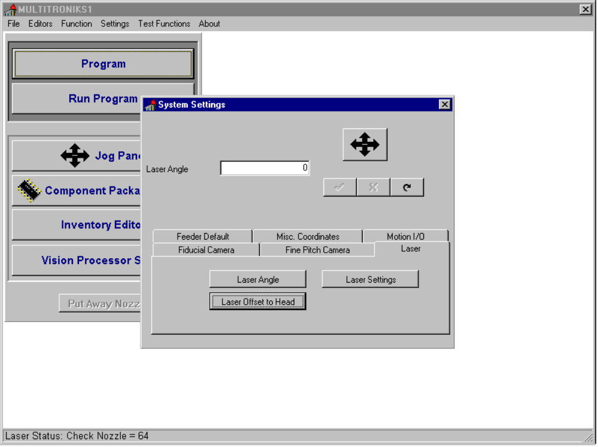
Figure 6
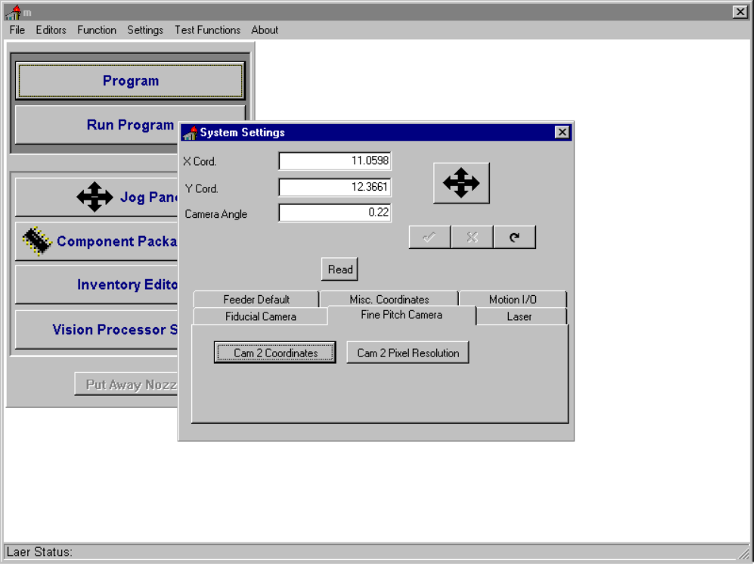
Figure 7

